What I did during the winter intersession:

* Clean up code
* Chessboard detection
* Get both and to work
* Automatically resize and re-position the image before warping so that it lands within the projection

Chessboard detection:

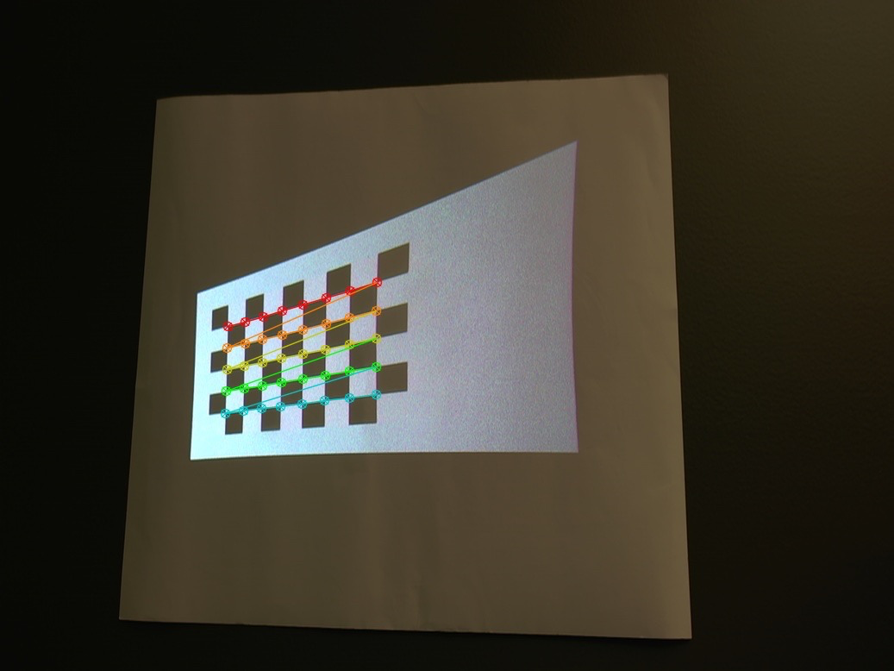

Auto-fitting the image prior to warping

* Get corners of the boundaries of the projection:

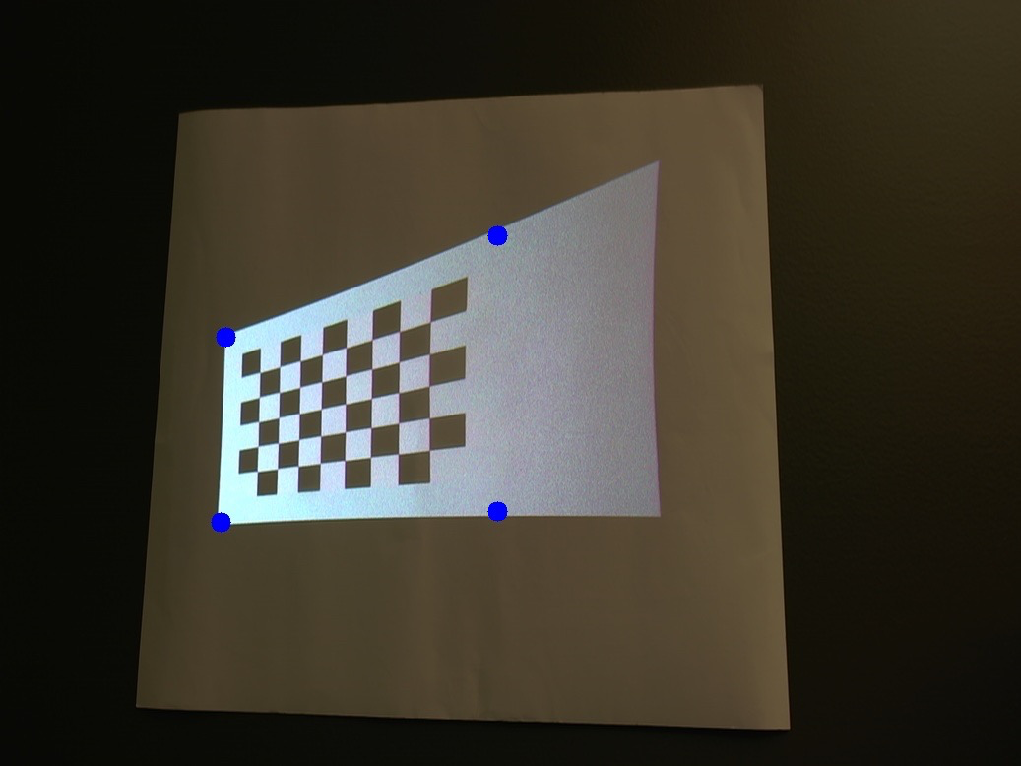

* Max. rectangle that fits inside the projection:

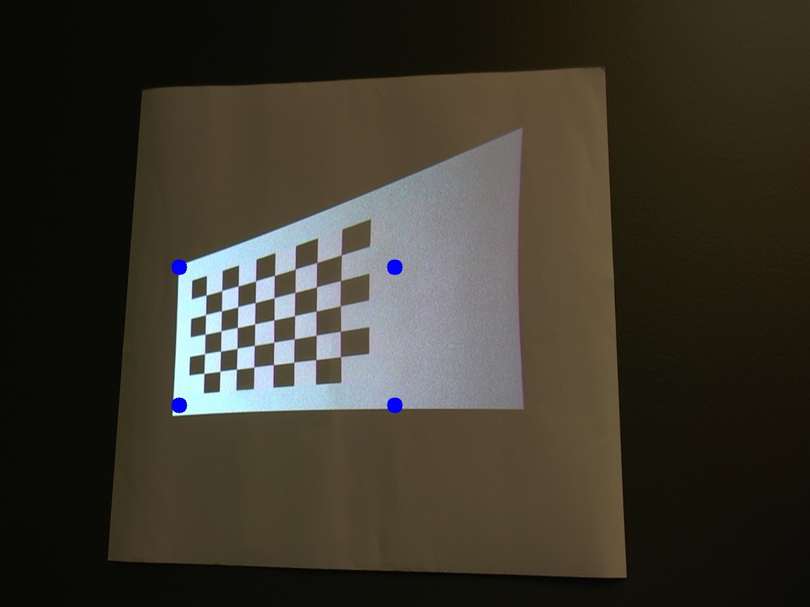

* pre_anamorph:

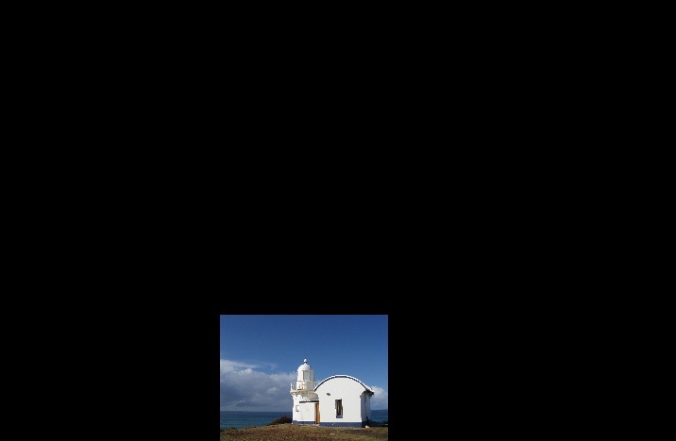

* anamorph (warped image):

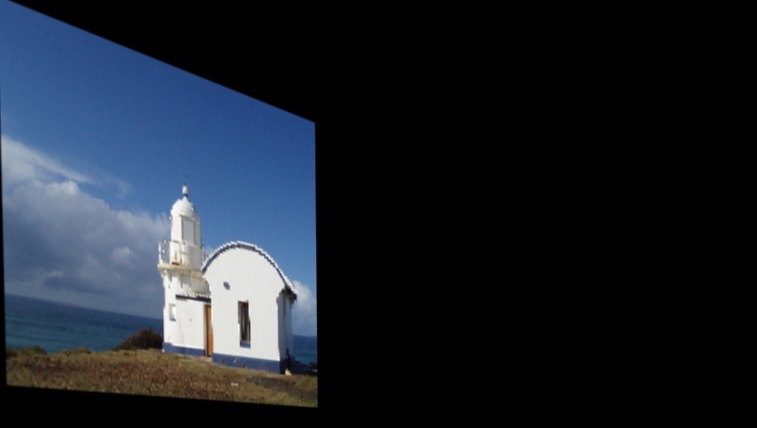

* check_anamorph (camera view when anamorph is projected):

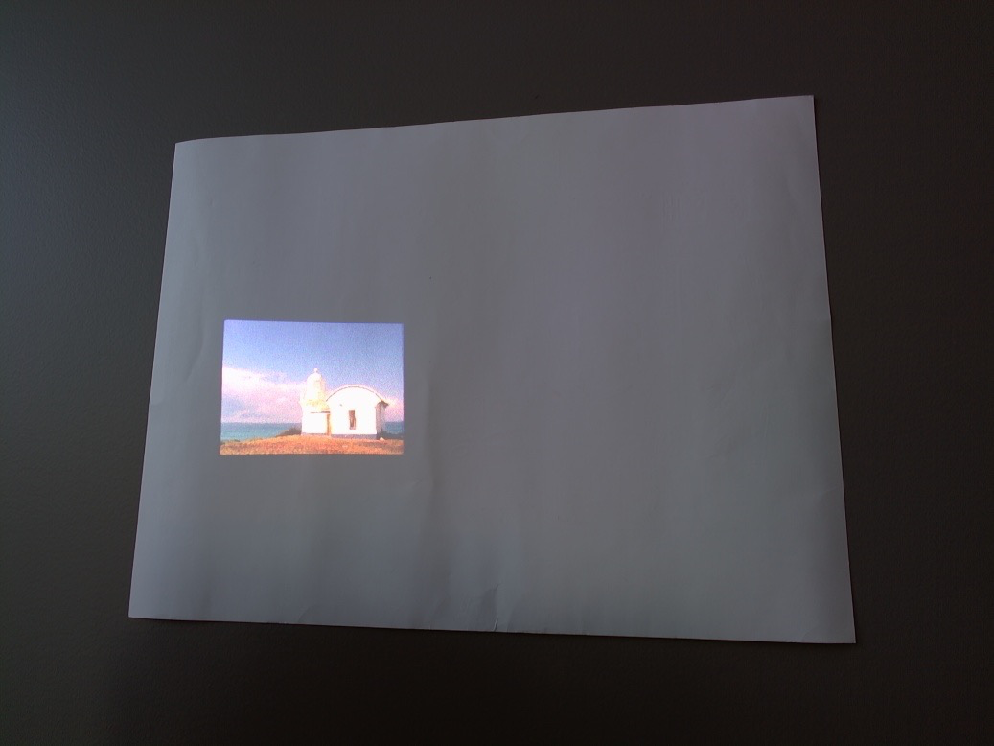

TODO: Multi-viewer problem (2 viewers)

* Method 1: average the homographies
* Method 2: calculate "error" for each viewer and have the program decide what homography minimizes that error (sum of error2)